**Lesson 03 Demo 01**

**Setting Up a Zapier Account and Creating a Zap**



Steps to be followed:

1. Set up a Zapier account
2. Create a Zap

**Step 1:** **Set up a Zapier account**

* 1. Go to Zapier.com and click on **Sign up**

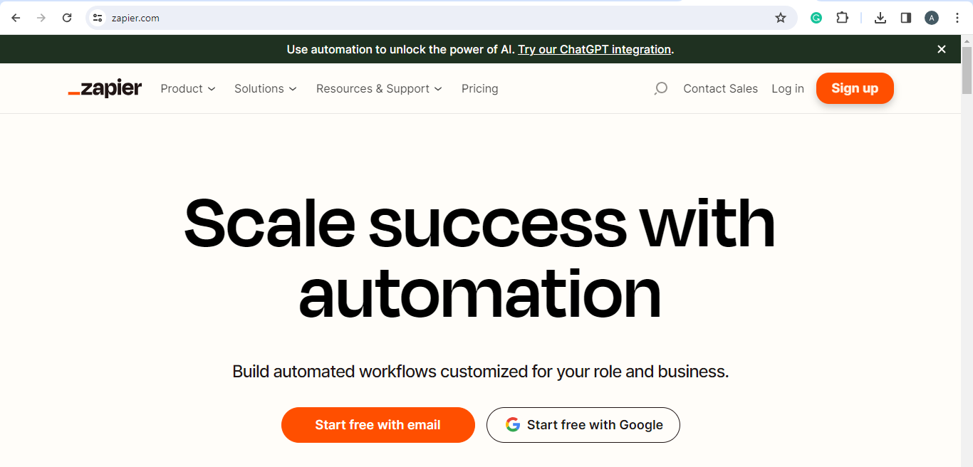

* 1. Enter the credentials

* 1. Enter the **Password**

* 1. Click on **Log in** next to the **Sign up** button

* 1. Enter the **Email** and **Password** and click on **Continue**

* 1. Choose your user role

* 1. Select the option that needs to be automated with Zapier

* 1. Select the apps you want to use

* 1. Choose the option that best reflects how familiar you are with automation

* 1. Select the company size

1.11 Select the job level

1.12 Select who will be using Zapier; in this case, select the **Just me** option

**Step 2: Create a Zap**

2.1 Navigate to the Zapier dashboard and click on **+ Create Zap**

* 1. Click on **Trigger**

2.3 In the **Change trigger** page, search for and select **Google Sheets** in the search bar

2.4 Under **Event** on the right panel, search and select **New Spreadsheet Row**

2.5 Click on **Account** and then select the Google account

2.6 Before selecting the next step, go to your Google Drive and make a spreadsheet with

the name **Lead data_sample**

2.7 Once your account is connected, select **Continue**

2.8 Under **Spreadsheet**, select **Lead data_sample**

This shall appear automatically, as your Google Sheets is linked to your Google Drive account.

In **Worksheet,** select **Sheet 1.**

2.9 Fill up a sample data in the spreadsheet, **Lead data_sample**

2.10 Click the **Test trigger** button to show the row data on Zapier

The following screen will appear:

2.11 Click on **Action**

2.12 In the **Change action** page, search and select **Gmail**

2.13 Under **Event,** search and select **Send Email**

2.14 Click on **Continue**

2.15 In the **To** section, select data from the sheet named **Lead data_sample**, which has an email ID stored

2.16 Select further action fields that you want to automate as shown below

2.17 Verify the data and click on the **Test step**

2.18 Zapier will act, and an email will be sent to the lead who has filled the form; click on **Publish**

The following screen will appear:

The email sent is shown below:



You will receive an email for creating your first Zap from Zapier.com as shown below:

By following these steps, you have successfully set up a Zapier account and created a Zap.